Yan Jiangyue 0930756
Pan Lijun 0930705
Chen Piao 0930810
Huang Zeqian 0930776
Li Pincao 0930772
Li Min 0930775
Tang Zhihao 0930765

Project Title: University Information Store And Analyze System

- Introduction
It is the “big-data” time. The key of “big data” is to collect data and analyze them. And these analization can be used to predict what’s the trend of something in the future. There are four properties of “big data”, they are volume, variety, value and velocity. (Big Data: Thinking and Going) This technology will be useful for cooperations, companies and governments. But there are also some problems to be dealt with. How to collect valid data? How to analyze them? How to use them to “predict” future? “Big data” can also be a waste. That is to say, if we can’t manage “big data” well it will become “big rubbish”.
Some professors mentioned that students should think what they will do after graduate, or even ten years from now. But this program will focus on more realistic issues. Actually sometimes the goal is not clear for many of the students. Another problem is that professors or advisors can not “understand” a student 100%. So it is normal that they provide some misleading or even wrong decisions for students. But meanwhile their opinions worth refering to. This phenomenon requires a system that collect and analyze “data” genrated by students. Say, if the system can analyze what a specified student did in the past year, for example, it can record this students’ hobby, courses he or she took and the scores he or she got. Then the system can probably discover that he or she is good at some courses and then it can give advices for his or her future study or future work. Simliar things can be done for professors. Professors are often worrying about what to research. But according to his or her reasearch work last time or several times before, we may find out that he or she maybe intrested in other areas and generate more topics for him or her. Faculties are always facing so much things that they’ll forget to do something sometimes. So there need a system to record things should be done today for him or her, so as the headmasters. Altogether, we can store tons of information into some data structure we learnt to collect and analyze “big data” around us.

- Key Functions and Components

- Student class
In the part of student class, the system will record students' hobby and personality. We will use course interface to store the ID, course name, garde, credit, LD_Grade, introduction and instructor. We will use faculty info interface to check and Sir II interface to modify. Students will also get some jobs, so we will use job plan interface, it contains job name, recommend level
salary and advice. As we can see in the picture, the hobby and personality can effect the information which are stored in the interface.

- Faculty class
As for the faculty part, when faculty log in with their account, they can check and modify the course information, such as course name, the introduction of course, course credit and give their students grade. Besides, they can edit their own information including their contact information which is shown to their students. They also can check but can not change the SirII part where their students evaluate them anonymously. The most common and useful part is that faculty can share projects with their students. The project part contains the name of project, due date, project information and so on. Moreover, faculty can give students recommendation on their job plan according to both project grade and their personalities.

- Admin
The admin users play the role of system manager. The admin users can check the information of the projects and SIR2. They can also modify the information of the courses, including changing the course name, time, information and the students’ grade. The admin user have the access to the task interface. Here the user can see different information of each tasks, such as due date, if it is emergency and the evaluation of their work. So the admin can know when and what are their jobs and finish them in time. The users can see the new information of the school on log in page.

- Head
The head users are the principles of the school. After log in to the system, the admin user can add or delete the student and faculty users. The head user can see school information on the log in page. They can modify the information of the tasks they give to the admin users, including adding tasks, setting the due date, writing the information of the task and notify if it is emergency. They can also give the evaluation of the performance of the admin users on the job. The head directly control the admin but do not have access to the other information that related to the specific course, project, SIR2 and the job plan of the student.

- Project Interface:
This special interface is set to allow students, professors and admins to check the information about project in the progress of the university. The interface includes Project name, progress, due date, cost, faculty name and student name. And each admin and faculty should implement the interface differently.

- Public property:
This will also be an abstract class extended by all the objects. Including each users name, password, identity, salary. Id, date come in the university, birthday and note of the person which includes the special information of the person.

- Design

- Software Structure Design:
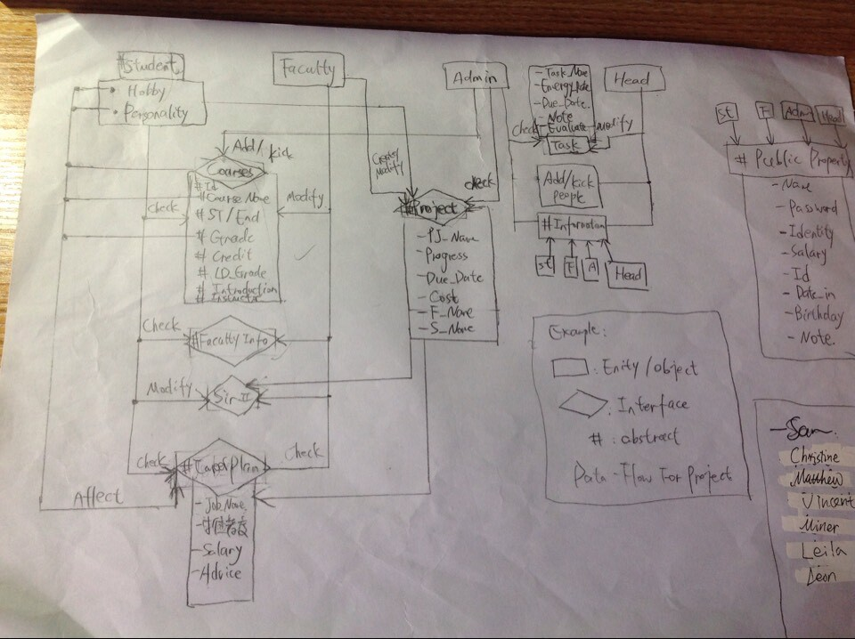

- Working assignment design:
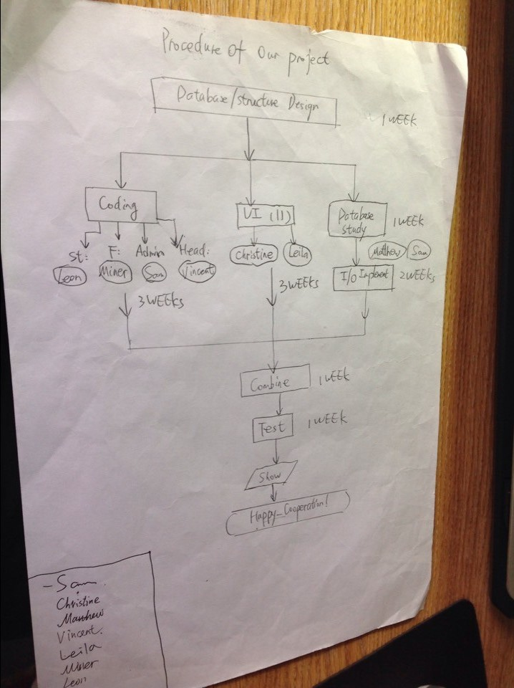

- The design of landing surface:

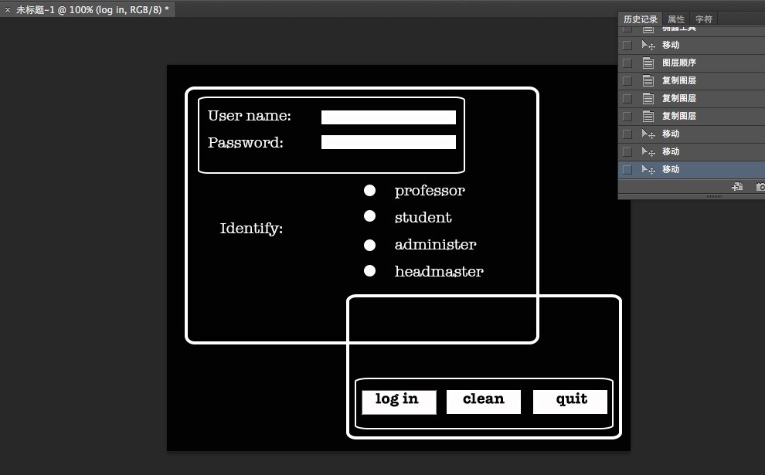

- Team members and job allocations:

Chinese Name | English Name | Job Allocation
Yan Jiangyue | Sam | Design and manage the whole project, coding all the interfaces related to the project. Plan and test the project.
Chen Piao | Christine | Design Graphic user interface for this project.
Pan Lijun | Matthew | Study the organization of datas, and implement the I/O part of the whole project. Give the algorithm of calculating the recommended level of a certain job.
Tang Zhihao | Vincent | Coding the admin part of the project.
Li Min | Miner | Coding the faculty part of the project
Li Pincao | Leon | Coding the student part of the project
Huang Zeqian | Leila | Help design the user-interface, help plan and test all the programs related to the project.

- Expected completion time line
As specified by the working assignment design, the data and structure design is already done by the end of last week. It means that the project already finish the design part. And the next part in the development process is implementation and testing. (National Computer Rank Exam CS201). The major problem of the implementation is the I/O part, it will take some time as well as efforts. The coding part, will also take 3 weeks . UI part takes similar time. But luckily, the 3 procedures are found can be done concurrently. So we plan to spend totally 3 weeks on coding, designing and I/O and database testing. Another week will be needed for combine all the results together and to improve. Finally, one week will be need to test the whole project, and one another week will be needed to write reports about our project and prepare to show our project. Altogether, we need from now totally 5 weeks and it is still a little bit tough. Here listed another table which matches our work with our time to make it more clear:

Task | Due Date
Coding, GUI Design, UI implementation | 23rd, Nov. 2014
Combine 3 parts together | 30th, Nov.2014
Whole Project Testing | 10th, Dec.2014
Preparing and Show Planning | 18th, Dec.2014 And can be shown on that day
Get feedbacks, improve and summary the project | 25th, Dec.2014

- References
- Magazine 2013 Programmer, Pulishing House of Electronics Industry, Beijing, China. Edit by Meng Yingxia, ISBN 978-7-121-22456-0, 2014-3 published. P.g. 10--11 Big Data: Thinking and going
- National Computer Rank Exam CS201: Basic knowledge of Data Structure and Software Engineering, HIGHER EDICATION PRESS, Beijing Edit by He Xinquan, ISBN 978-7-04-037232-8

